**1. INTRODUCTION**

* 1. **Project Overview**

The main purpose of this project is to build a smart machine learning system that can accurately recognize different fabric patterns from images. By using transfer learning, the project shows how powerful deep learning can be for image classification tasks. It also includes a simple web application made with Flask, where users can upload fabric images and get instant predictions. This project connects machine learning with real-world use, making fabric pattern identification quick, easy, and accessible. It aims to help designers, manufacturers, and retailers by saving time and improving accuracy in classifying fabrics.

This is a project designed to automate the process of identifying and categorizing fabric patterns using advanced deep learning techniques.

* **Scenario 1:** Fashion Industry

In the fashion industry, designers and manufacturers often deal with a wide range of fabric patterns. Pattern Sense can automatically classify different patterns like stripes, polka dots, floral prints, and geometric designs, saving time and effort in manual categorization.

* **Scenario 2:**Textile Quality Control

Textile companies can use Pattern Sense for quality control purposes. By analyzing fabric patterns, the system can detect any irregularities or defects in the patterns, ensuring that only high-quality fabrics are sent for production or distribution.

* **Scenario 3:**Interior Design

Interior designers frequently work with fabric patterns for furniture, curtains, and upholstery. Pattern Sense can assist designers in quickly identifying and selecting suitable fabric patterns that match their design concepts, leading to more efficient project workflows.

**1.2 Purpose of the Project**

The primary purpose of the *Pattern Sense* project is to develop an intelligent deep learning system that can automatically classify different types of fabric patterns from images. This model aims to assist industries such as fashion, textiles, and e-commerce by enabling accurate and fast identification of fabric designs like floral, stripes, polka dots, etc., thereby reducing manual effort and improving operational efficiency.

**Key Objectives:**

* Automate fabric pattern recognition using computer vision.
* Improve classification accuracy using transfer learning and CNNs.
* Build a user-friendly prediction system that can process fabric images with high precision.
* Enable integration into real-world applications like fabric inventory systems or visual search engines.

**2. IDEATION PHASE**

2.1 Problem Statement

2.2 Empathy Map Canvas

2.3 Brainstorming

**3. REQUIREMENT ANALYSIS**

3.1 Customer Journey map

3.2 Solution Requirement

3.3 Data Flow Diagram

3.4 Technology Stack

**4. PROJECT DESIGN**

4.1 Problem Solution Fit

4.2 Proposed Solution

4.3 Solution Architecture

**5. PROJECT PLANNING & SCHEDULING**

5.1 Project Planning

**6. FUNCTIONAL AND PERFORMANCE TESTING**

6.1 Performance Testing

**7. RESULTS**

**7.1 Output Screenshots**

The complete execution of the Pattern Senseapplication is shown in the images step by step as shown below.

**Step 1:** Run the app.py code and you will get a link in terminal as <https://127.0.0.1.5050> to access web page and to do the other process.

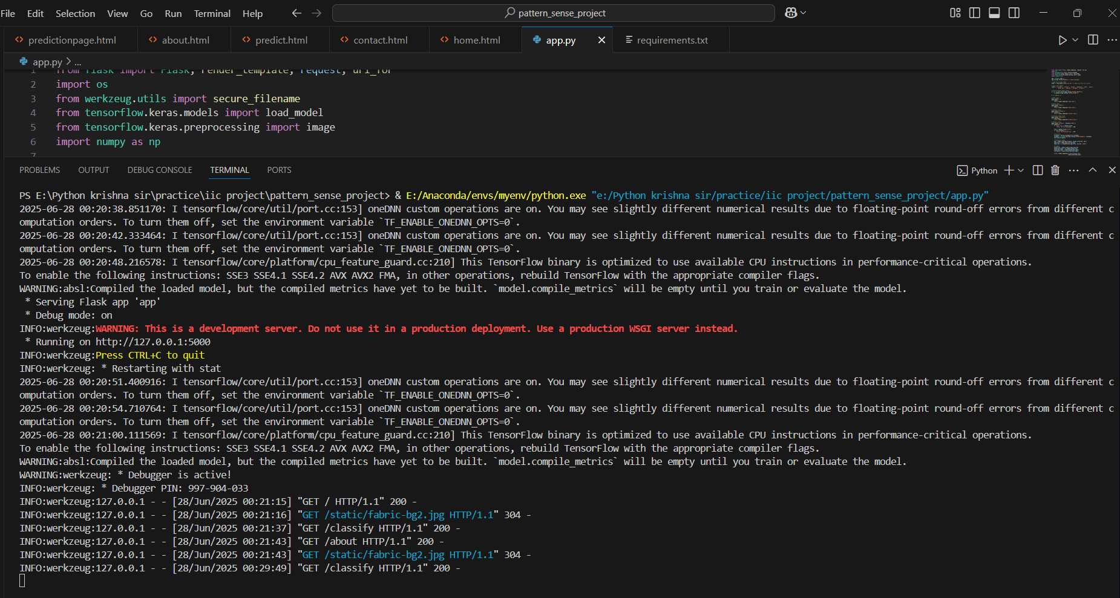

**Fig 7.1.1: Code running in Terminal**

**Step 2:** Click on that link a web page of Pattern Sense will be open in the web browser.

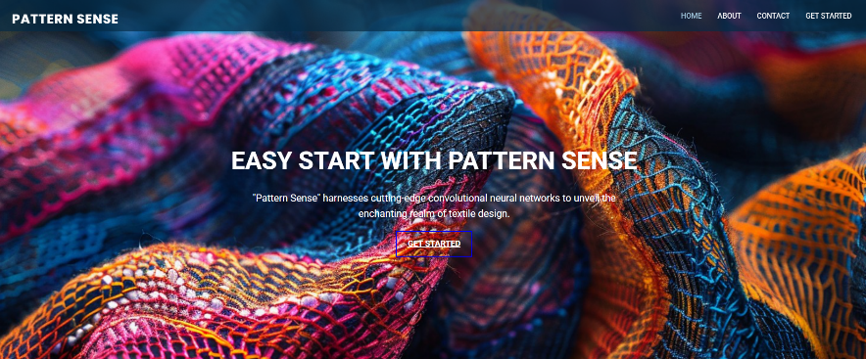

**Fig 7.1.2: Pattern Sense Home Page**

**Step 3:** Click on GET STARTED option to open the prediction page.



**Fig 7.1.3: Prediction page in Pattern Sense**

**Step 4:** Click on choose file option to choose the images that need to predict.

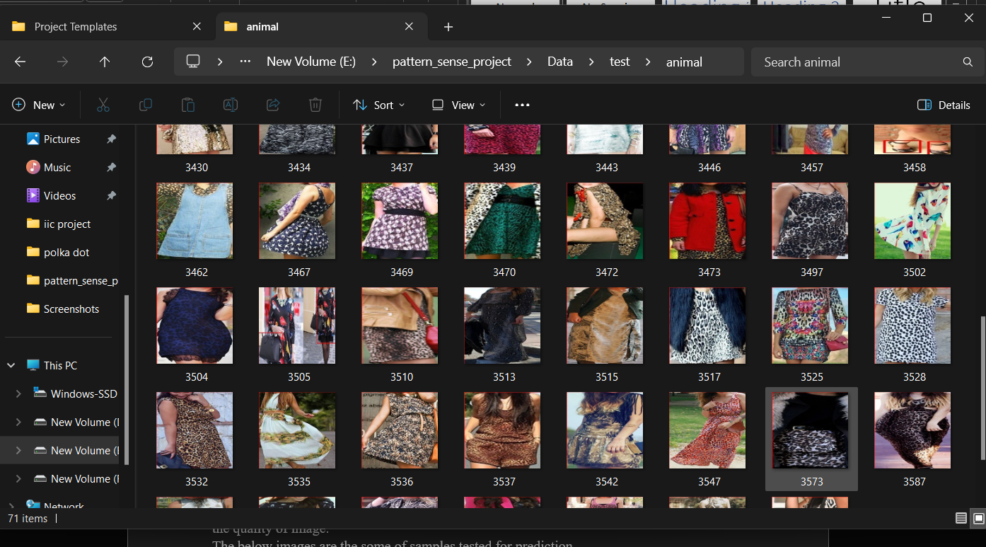

**Fig 7.1.4: Window to choose image for prediction**

Select any image for prediction and click on Open.

**Step 5:** Click on Predict to predict the quality of selected image.

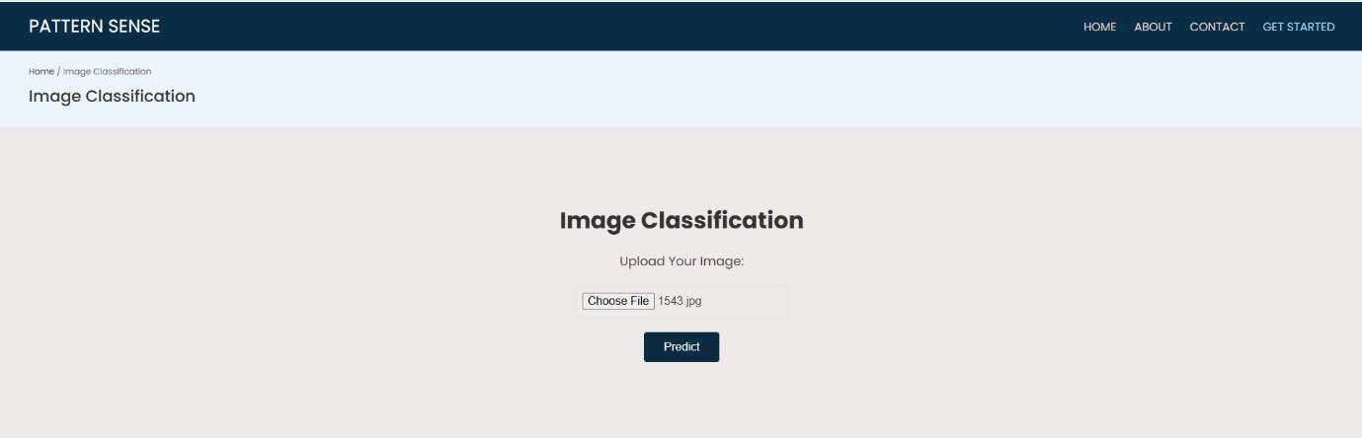

**Fig 7.1.5: Image selected in prediction page**

**Step 6:** After clicked on the predict button the model predicts the image quality and displays the quality of image.

The below images are the some of samples tested for prediction.

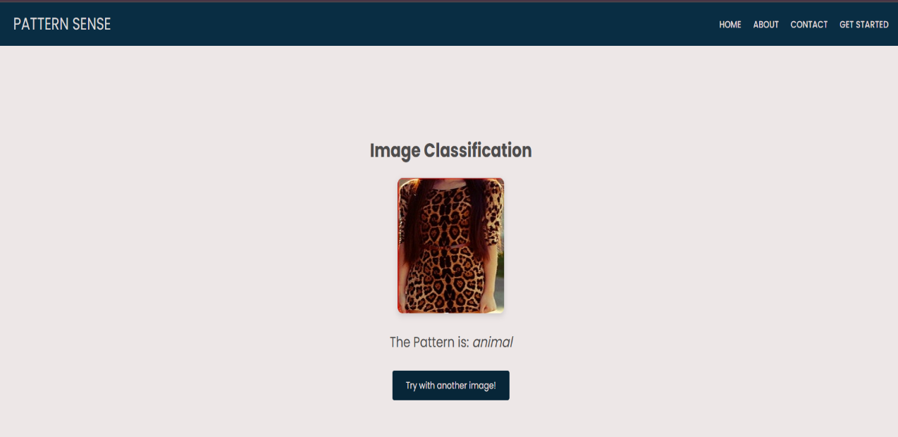







**Fig 7.1.6: Prediction output for the several inputs with accuracy**

After the Images Predicted the images will be stored in the uploads folder as shown in the figure given below.

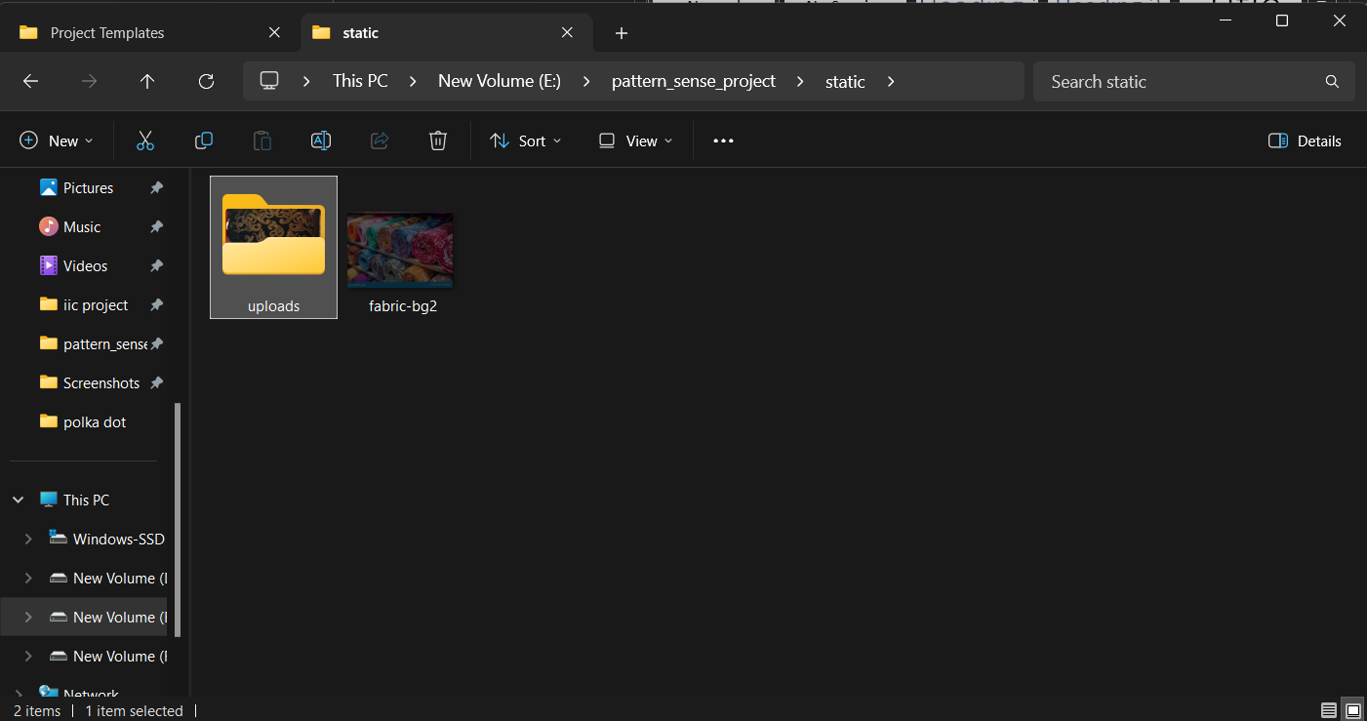

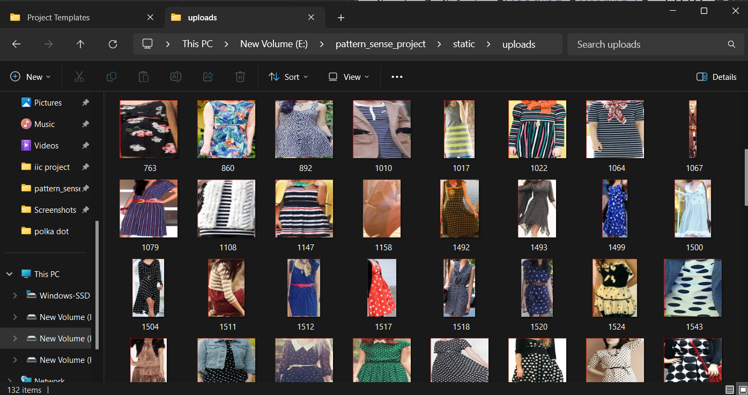

**Fig 7.1.7: Folder Structure to store predicted images**

**8. ADVANTAGES & DISADVANTAGES**

**8.1 Advantages of Pattern Sense project**

| **Advantage** | **Description** |
| --- | --- |
| **Automation of Classification** | Reduces manual effort in tagging fabric patterns, which is useful in textile industries and e-commerce. |
| **Fast & Scalable Predictions** | Once trained, your model can quickly classify thousands of images with minimal delay. |
| **User-Friendly Web Interface** | Your Flask app allows users to upload images and get results instantly — no technical skills needed. |
| **Reusable Model** | The trained model (model_cnn.h5) can be reused across platforms like mobile apps or integrated into inventory systems. |
| **Scalability** | Can be integrated into various environments with minimal effort. |
| **Data-Driven Decisions** | Provides objective, consistent results reducing human error. |
| **Cost Savings** | Instead of paying textile or design experts to manually inspect and label fabric patterns, your model does it in seconds — saving recurring labor costs. |

**Table 8.1: Advantages**

**8.2 Disadvantages / Limitations**

| **Disadvantage** | **Description** |
| --- | --- |
| **Dependence on Image Quality** | Poor image quality or improper lighting can reduce prediction accuracy. |
| **Initial Setup Cost** | Requires investment in model development, hardware, and infrastructure. |
| **Limited to Trained Categories** | The model only works for certain fabric patterns it has been trained on. |
| **External Factors** | Complex external factors like hidden defects cannot be detected. |
| **Requires Technical Expertise** | Maintaining, updating, and troubleshooting the AI system requires skilled personnel. |

**Table 8.2: Disadvantages**

**9. CONCLUSION**

The *Pattern Sense* project has demonstrated a practical and intelligent solution for fabric pattern classification using deep learning techniques. By training a Convolutional Neural Network (CNN) and applying transfer learning with models like ResNet50, the system is capable of recognizing and classifying fabric images into various predefined categories such as floral, ikat, stripes, and polka dot with appreciable accuracy.The integration of a user-friendly web interface using Flask enhances accessibility for end-users to upload images and instantly receive predictions. This automation significantly reduces manual effort, minimizes errors in classification, and contributes to operational cost savings in textile industries.While the model achieves promising accuracy, further improvements can be made by increasing dataset diversity, performing hyperparameter tuning, and deploying the system on cloud platforms for scalability. Overall, the *Pattern Sense* project sets a strong foundation for future development in intelligent textile inspection and classification systems.